
Component Model
Move to target
Robotic Cognition System for Wheelchair
Unicamp

Table of Contents
1 Purpose of this Document 3
2 Component Design 4
2.1 Purpose 4
2.2 System Diagram 4
2.3 Component Input 4
2.4 Component Output 4
2.5 Component Processing 4
3 Component Execution 6
4 References 8

Document Information
Project Name: | Robotic Cognition System for Wheelchair
Prepared By: | Tarcísio Franco de Carvalho | Document Version No: | 1.0
Title: | Component Model – Move to target | Document Version Date:
Reviewed By: |  | Review Date:
Distribution List
From | Date | Email

Acronyms
Acronym | Description
ROS | Robot Operational System
AMCL | Adaptative Monte Carlo Localization

Document Version History
Version  Number | Version  Date | Revised By | Description | Filename

Purpose of this Document
Define how the related component works and its relation in the main system.

Component Design

Purpose
This component is responsible to request the wheelchair robot to move to a desired target point using path planning, avoiding collisions with objects.

System Diagram

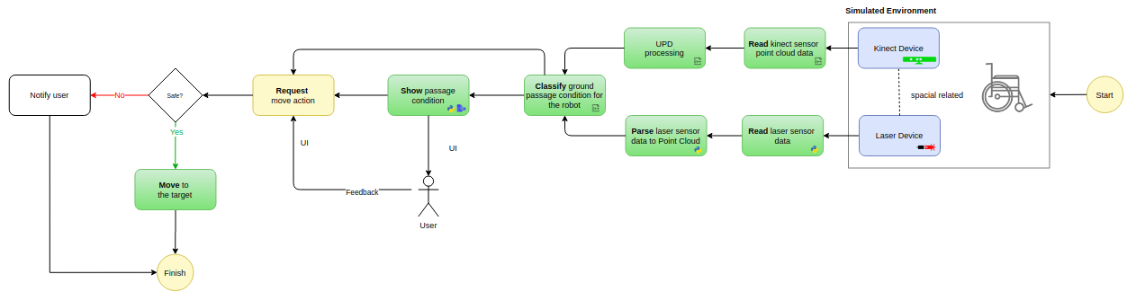

Component Input
This component needs the following input data:
- Current laser pan angle
- Current laser tilt angle

Component Output
This component will move the wheelchair robot base to the target point, where it is defined in meters in x and y axis direction from the current robot position. This target point is calculated based on laser pan and tilt angle information.

Component Processing
This component has relationship with the move_base/goal ROS node that is part of ROS navigation stack. The diagram below shows this relationship:

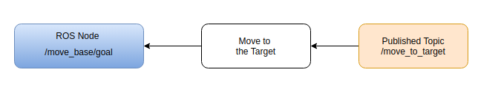

Below the main process flow for this component that occurs in cycles:

- Convert the laser orientation data to X and Y axis point direction
- Set X and Y meters ahead to /move_base/goal node
- Monitor requested action completion and publish it’s status

Component Execution

To execute this component is necessary the Gazebo simulation environment, ROS main process running and the Rviz tool to show processed data. Bellow the steps to run this component:

- Start Gazebo environment simulation
On the project root folder, run the script ./sim_model/scripts/launch.sh it will process the simple_blocks.world and sim_model.urdf.xacro files

Result
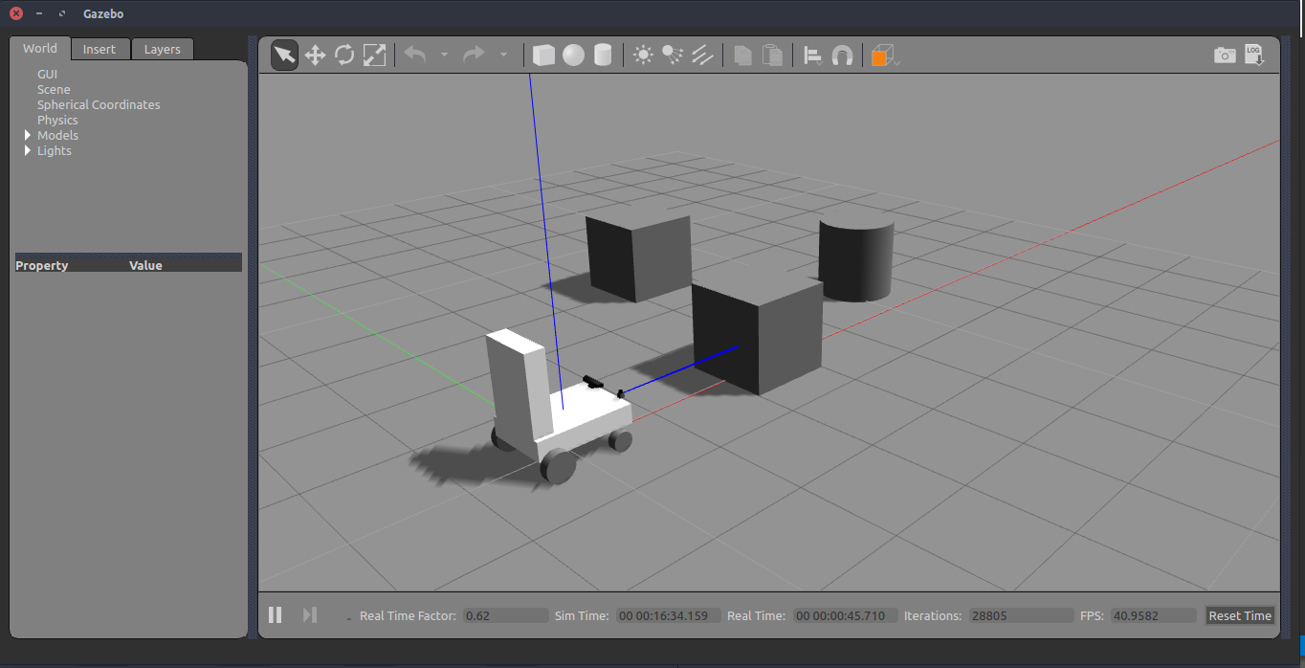

- Start the UPD processing component

On the project root folder, run the script ./upd_run.sh it will start a node to published UPD data

Result
In Rviz the UPD data is being showing.

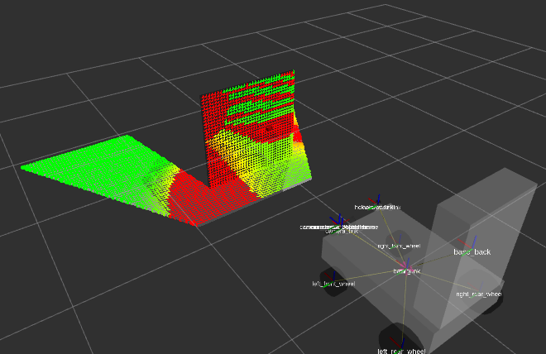

References

- Navigation
  - Move Base ROS: http://wiki.ros.org/move_base?distro=noetic
  - Setup in ROS: http://wiki.ros.org/navigation/Tutorials/RobotSetup
  - ROS base local planner: http://wiki.ros.org/base_local_planner
  - ROS and Gazebo Tutorial: http://wiki.ros.org/action/fullsearch/urdf/Tutorials/Using%20a%20URDF%20in%20Gazebo?action=fullsearch&context=180&value=linkto%3A%22urdf%2FTutorials%2FUsing+a+URDF+in+Gazebo%22
- Transform
  - Spherical Coordinates to Cartesian: https://www.mathworks.com/matlabcentral/answers/427558-how-can-i-create-xyz-coordinant-from-pan-tilt-system-angles
- Book - Learning Robotics using Python – Second Edition – By Lentin Joseph

